User Guide for Compensation Comparison Calculator
You can access the login screen for the calculator, here:
http://devrebuild-calculator.ropella.local/public/login?login=required
After logging in to the site, you will come to the Dashboard. You’ll see a vertical menu on the left as well as a horizontal menu on the right. You can navigate between the Dashboard, Company Offers, and Candidates pages using the tabs at the top of the page.
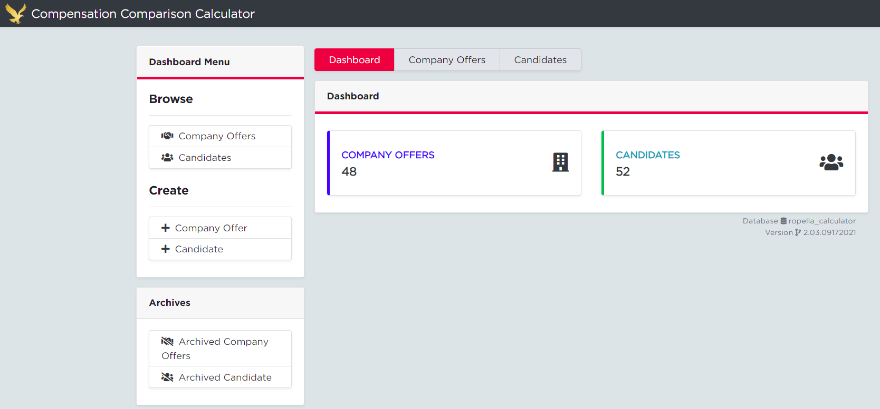
You can toggle back and forth between the hiring company and the candidate by using the tabs, as well as when you link the two together (more on that in a moment).
STEP 1: Create a new offer by navigating to the Company Offers tab and clicking “Create Company Offer.” This will take you to a separate page where you will input the Company Name, Offer Title (the role being filled), and Assignment Number (from FileFinder). Once your offer is created, it will be added to the drop down list and you can choose the company from there. You may also search the company by name using the search feature.
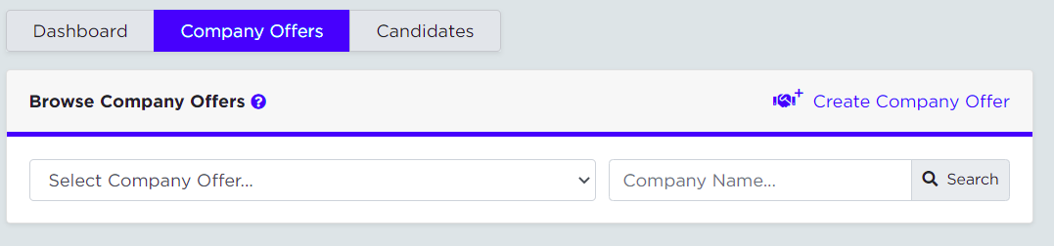
STEP 2: Create a new candidate by navigating to the Candidates tab and clicking “Create Candidate.” This will take you to a separate page where you will type the candidate’s name (first and last) as well as link an existing Company Offer. By linking the candidate to a company offer, you will be able to show a direct comparison between the compensation packages and create the report to show the hiring company.
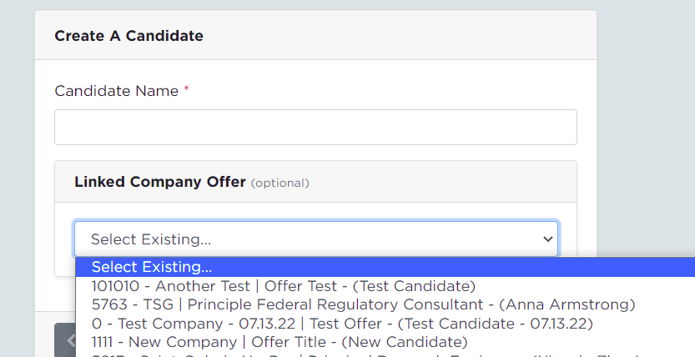
Note: you can only link a company and candidate through the Candidates tab.
Once your candidate is created, they will be shown in the drop down list. You may also search the candidate by name using the search feature.

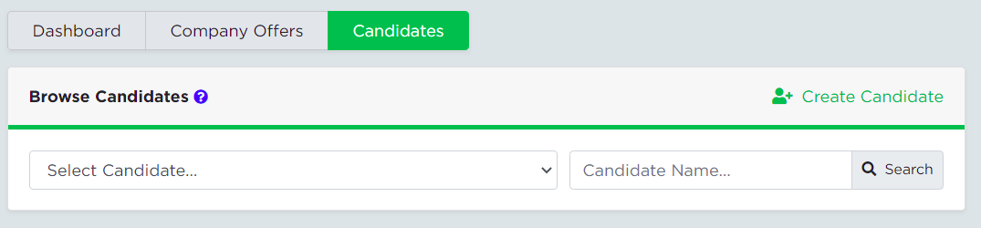
STEP 3: Once your Candidate and Company Offer have been created and linked, you will start plugging in the information for the respective compensation packages/offerings. For each field, you can click the (information) icon for instructions and guidance on how to complete that field and why it’s important. The (understanding) icon will give you a better understanding of what the field is asking for or definitions on certain topics.
Note that these forms save-as-you-go, so there is no need to hit the save button since the fields are saved each time an update is made.
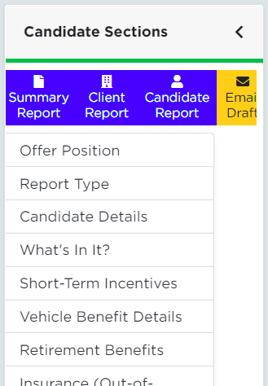
STEP 4: The menu on the left side of the pages will have shortcuts to each section of the offer/package. On the candidate’s menu, you will also see options to create the different comparison reports and email draft to send to the hiring team. Once you have all the details put in for each field for both the candidate and the linked company, you will create the client and summary reports in order to send to the hiring team and present the offer strategy.

Getting a report
Once you select a report from the top of the Candidate Sections menu, you’ll be able to toggle between the different reports at the top of the page. You can also go back to the Candidate Compensation section or print the selected reports.
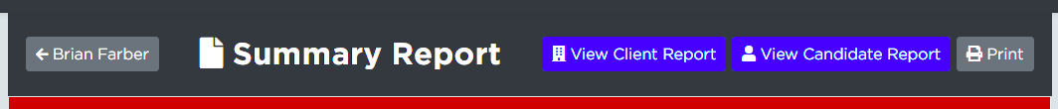
Types of Reports
Summary Report – This report shows a brief summary of the key highlights in the comparison. The Candidate Overview section includes the “What’s in it for the company?” and “What’s in it for the candidate?” sections, as well as the breakdown of the Offer Acceptance Strategies. It will also contain the visual bar graph making the comparison much easier to see and any “Important Topics to be Aware of” that you’ve selected. Example Summary Report shown here:
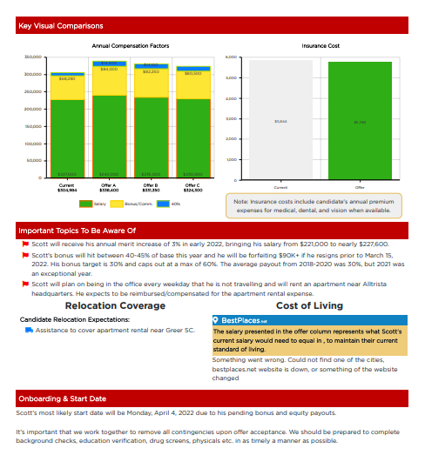
Client Report and Candidate Report – These reports are identical in content and layout and offer a detailed comparison (in table form). These reports can be used to send to the hiring team of the client company and the candidate, respectively.
The key difference between the Client Report and Candidate Report is which row you choose to show or hide. While the information is the same, you have the option to customize what is visible to the client and candidate in two separate documents instead of having to go back and forth in one document hiding/unhiding rows.
Example Client/Candidate Report shown here:
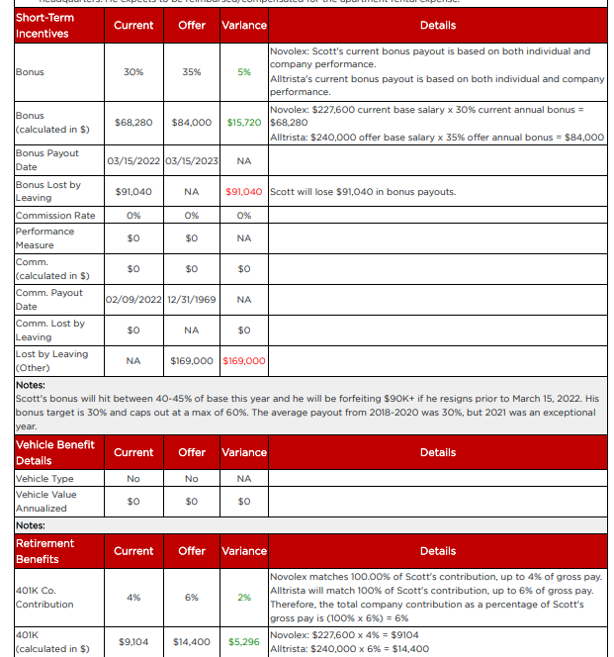

The candidate/client report covers each section of the calculator, using the details you have entered for both the company making the offer and the candidate receiving the offer. For each line, you will see the title of the section, what the candidate currently has, what the offer will be, any variance between the two, and details or notes regarding those differences.
Note: this is why it’s important to fill in the “Notes” fields of the calculator!

In each type of report, you can use the pencil icon to the left of each field to make any edits. It will take you back to that section in the Candidates view to make any changes. If there is any information that is not relevant or that you don’t want to show in the comparison, you may use the eye icon to the right to hide that line.
Hide
Edit
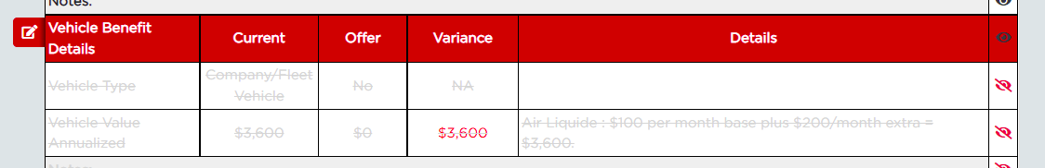

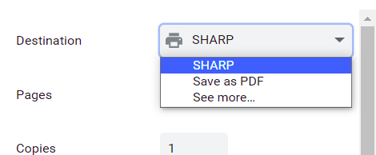
To generate the reports, click the Print option at the top of the screen to pop out the print option box. Change the Destination field from the printer to “Save as PDF” and click “Save” at the bottom of the window to save the file in the respective Job Orders folder for that search.
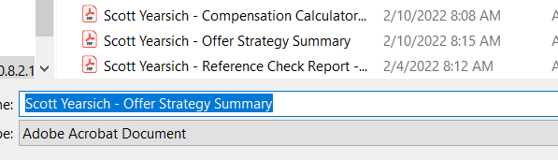

Email Draft
The last tab at the top of the Candidate Section Menu is the Email Draft. This generates a template email to use when sending the Compensation Calculator Report to the client. The page will show you what to include as the subject line of your email, what attachments to send, and the draft of the email. Copy and paste the content into a blank email draft. As with any template, be sure to read it through and tailor accordingly before sending it!
